**Test Report**

**Test case 1.**

In the first test case, I created a function for addition of two numbers, in which two input numbers were 12 and 8. The result should’ve been 20. The result is shown in the screenshot below, one is pass and other one is failed. The failed is with expected output 10, which is wrong.

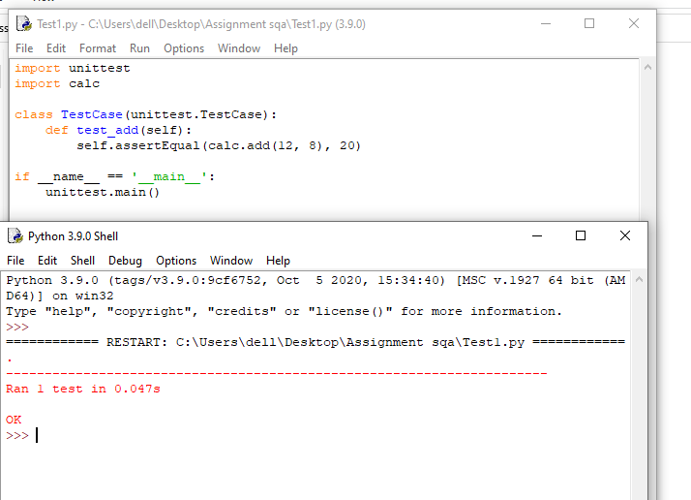

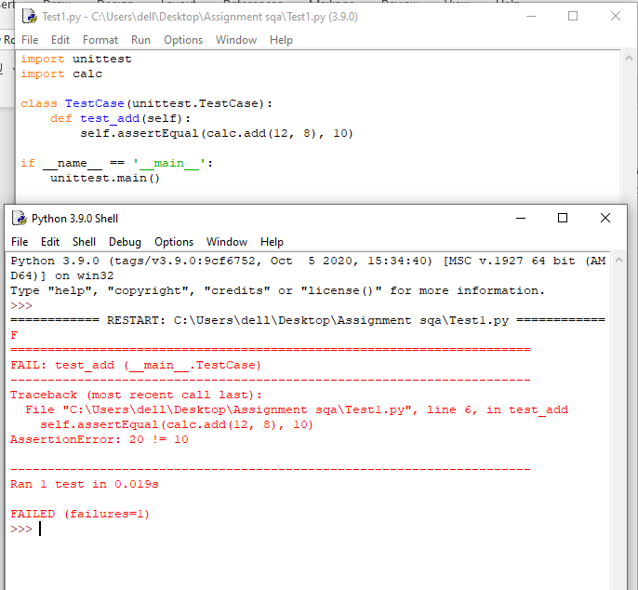

**Test case 2.**

In the second test case, I created a function for multiplication of two numbers, in which two input numbers were 3 and 10. The result should’ve been 30. The result is shown in the screenshot below, one is pass and other one is failed. The failed is with expected output 40, which is wrong.

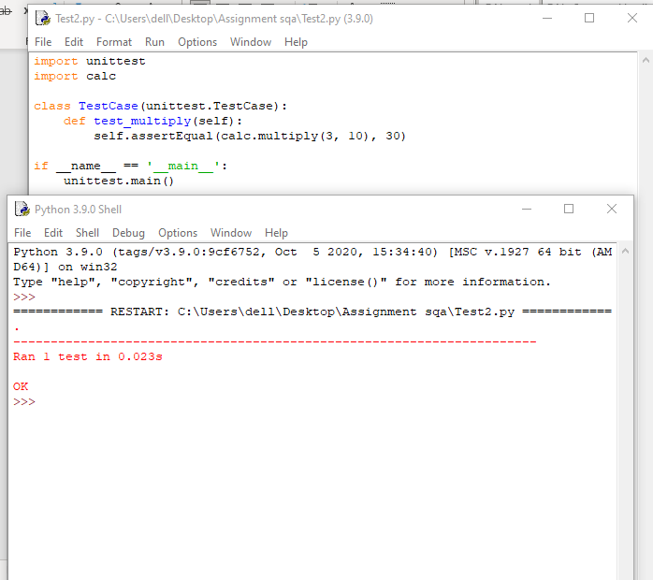

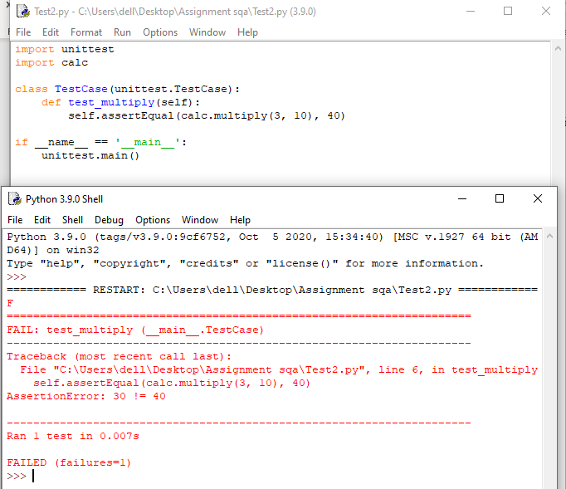

**Test case 3.**

In the third test case, I created a function for confirmation of upper-case letters as input. I used my name Usama and changed into uppercase and for the testcase, provided expected output as USAMA. The pass and failed test are shown as the result.

**Test case 4.**

In the fourth test case, I created a function for confirmation of lower-case letters as input. I used my name USAMA and changed into lowercase and for the testcase, provided expected output as usama. The pass and failed test are shown as the result.

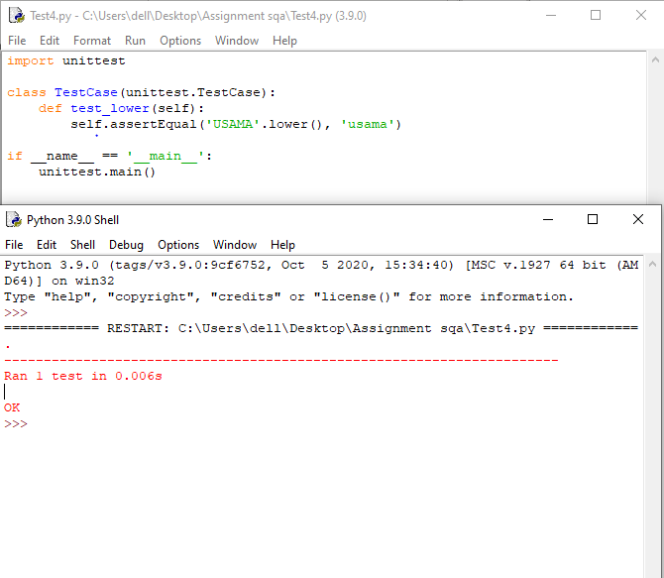

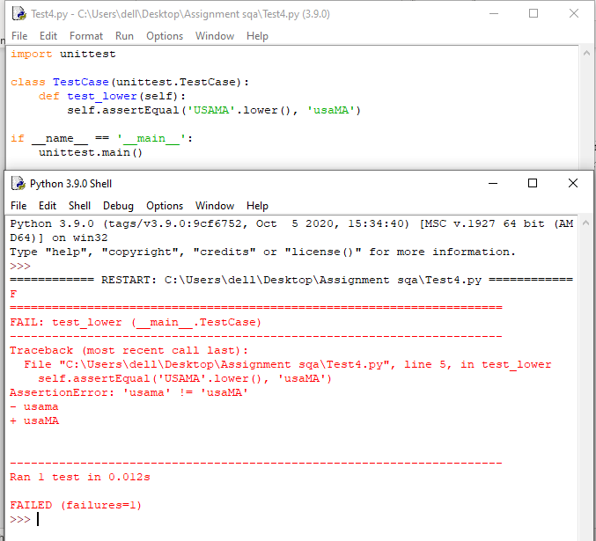

**Test case 5.**

In the second test case, I created a function for subtraction of two numbers, in which two input numbers were 10 and 2. The result should’ve been 8. The result is shown in the screenshot below, one is pass and other one is failed. The failed is with expected output 6, which is wrong.

